NITHIN S
221IT085

IT250 Lab Assignment 3

Q1) Mainu's friend Maithili gave him a bag with N strings. All the strings are binary which are made up of 0's and 1's
only. Maithili decides to consider the strings in the bag which have an odd number of 1’s and even number of 0’s
as Accepted otherwise Rejected. Maithili wants to know the Accepted and Rejected strings from the bag and
their count also. Mainu got very confused by all this, so he asked for your help.

CODE

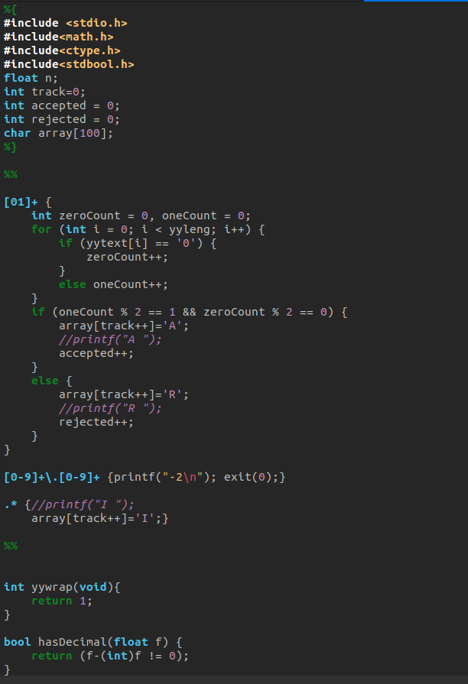

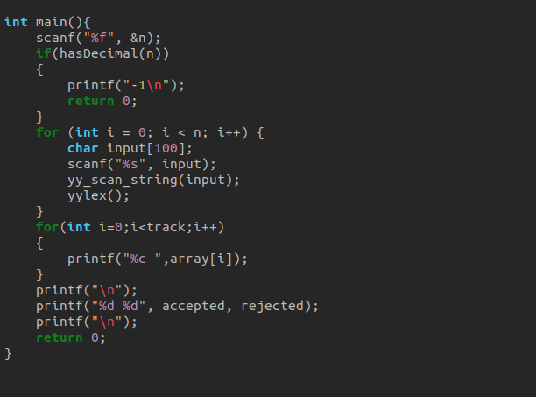

OUTPUT

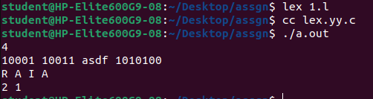

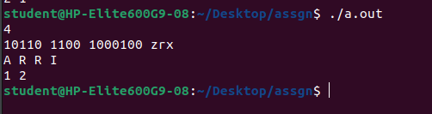
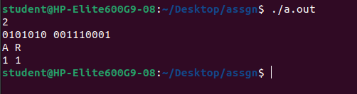
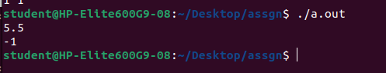
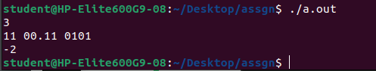

Q2) Ehan has a set of strings S consisting of a’s and b’s, as only characters. Ehan is a sorted person, he does
not like randomness, so when he looks at the string and finds that symbols in the strings are in random
order. He wishes to check for the valid and invalid strings, based on the condition : valid string - the
string consists of alternate a's and b's, otherwise it is invalid. And also he finds String S1 with a
minimum number of symbols from the string set S.

CODE

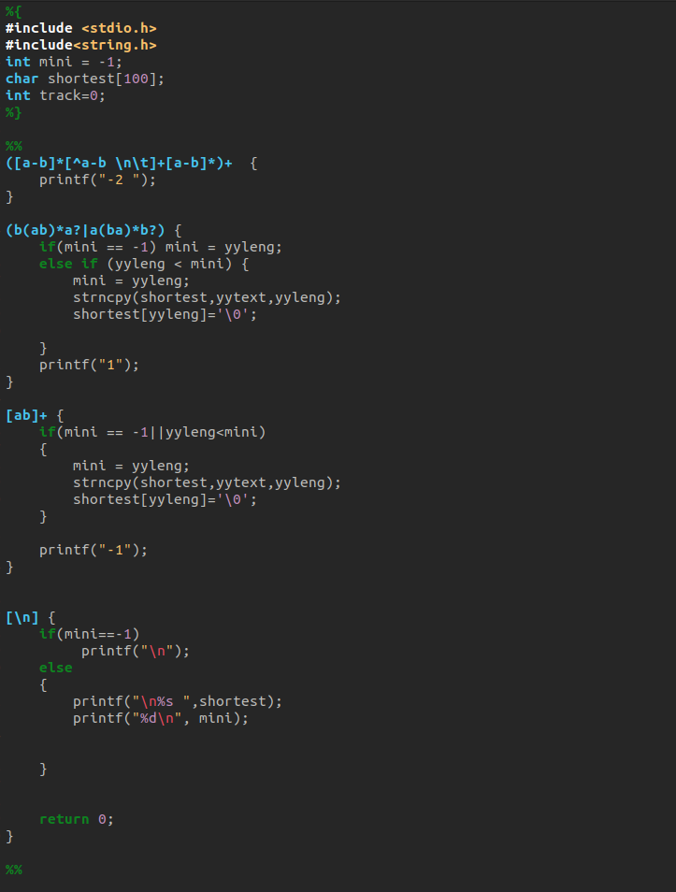

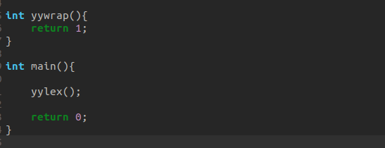

OUTPUT

